Understanding Dementia: Symptoms, Causes, and Early Warning Signs – H1
Author – Dr. Pankaj Totala, Consultant, Neuro Surgery
P1 | What is dementia?
P2 | dementia treatments
P2 | causes of dementia
P2 | early signs of dementia
P2 | memory loss in dementia
P2 | mental function
P2 | types of dementia
P2 | symptoms of dementia
P2 | best neurologist hospital in pune

Title: What is Dementia? Symptoms, Causes & Treatment
Description: Dementia is a condition affecting memory, thinking, and behaviour, interfering with daily life. Learn about its causes, progression, and impact.
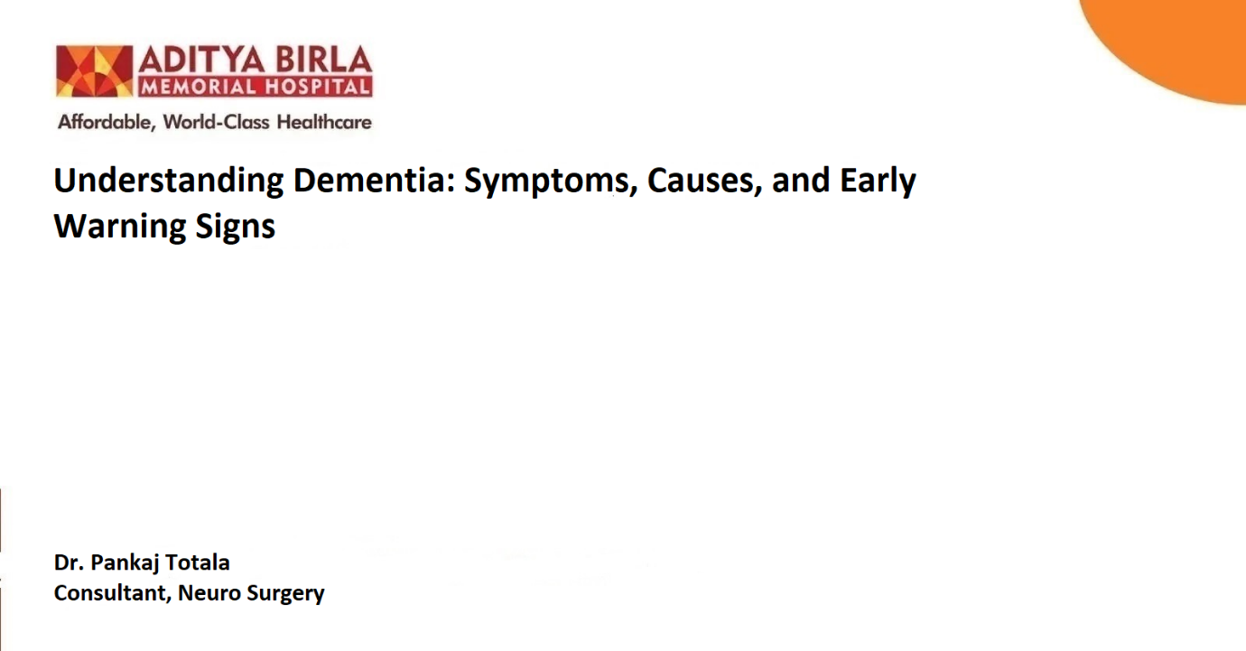

Dementia is a complex condition that affects millions of people worldwide, impacting their memory, mental function, and overall quality of life. While it is commonly associated with ageing, dementia is not a normal part of growing older. Early detection and intervention play a crucial role in slowing its progression and improving outcomes. In this blog, we will explore what dementia is, its causes, early signs, types, symptoms, and available treatments. If you or a loved one are experiencing symptoms, seeking guidance from medical professionals is vital.
What is Dementia? – H2
Dementia is not a single disease but a general term for a decline in mental function severe enough to interfere with daily life. It affects memory, thinking, reasoning, and behaviour. Dementia often progresses over time, leading to challenges in performing even routine tasks.
The condition results from damage to brain cells, which disrupts communication between brain regions. This damage can occur due to several underlying causes, which we will discuss further in this blog.
Causes of Dementia - H2
Dementia damages brain cells and interferes with your ability to communicate. Different regions of the brain are responsible for specific functions like memory, judgment, and movement. If cells in a particular region are damaged, that region cannot perform its functions normally.
Most brain changes caused by dementia are permanent and worsen over time. However, memory problems or thinking issues caused by the underlying conditions can improve if treated early.
Early Signs of Dementia - H2
Recognizing the early signs of dementia is crucial for timely diagnosis and intervention. Some of the initial warning signs include:
- Memory loss in dementia is one of the earliest signs. Individuals forget recent events, appointments, or conversations.
- Struggling with routine activities like cooking, driving, or managing finances.
- Individuals may lose track of dates, seasons, or their surroundings.
- Trouble finding the right words, following conversations, or repeating sentences.
- Poor Judgment and Decision-Making ability
- Sudden changes in mood, withdrawal from social activities, or irritability.
- Placing belongings in unusual spots and struggling to retrace steps.

Symptoms of Dementia - H2
As dementia progresses, the symptoms of dementia may become more pronounced and affect various aspects of life, such as:
- Increasing difficulty remembering names, faces, or important information.
- Struggling with problem-solving, planning, and logical thinking.
- Anxiety, depression, agitation, or paranoia.
- Inability to express thoughts clearly or understand conversations.
- Difficulty with balance, coordination, or walking.
- Getting lost in familiar places or forgetting one’s location.
- Challenges with dressing, eating, or maintaining hygiene.
The severity of symptoms often depends on the type of dementia and the stage of progression.

Types of Dementia - H2
While dementia is an umbrella term, there are several types of dementia based on the underlying causes:
- Alzheimer’s Disease: Progressive memory loss, confusion, and behavioural changes.
- Vascular Dementia: Cognitive decline due to reduced blood flow to the brain.
- Lewy Body Dementia: Marked by hallucinations, tremors, and sleep disturbances.
- Frontotemporal Dementia: Personality changes, loss of social inhibitions, and language problems.
- Parkinson’s Disease Dementia: Occurs in individuals with Parkinson’s, affecting memory and movement.
- Mixed Dementia: A combination of multiple forms, making diagnosis challenging.
Dementia Treatments - H2
While dementia currently has no cure, several dementia treatments focus on managing symptoms, improving quality of life, and slowing its progression.
- Medications – H3
- Acetycholinesterase Inhibitors: These drugs, like Donepezil and Rivastigmine, help improve memory and cognitive function.
- NMDA Receptor Antagonists: Medications like Memantine help regulate brain activity and support daily functioning.

- Therapies – H3
- Cognitive Stimulation Therapies: Exercises that stimulate thinking and problem-solving.
- Cognitive Rehabilitation: This therapy helps in early stage of dementia. It focuses on stimulating the part of the brain that functions to support the parts that are damaged.
- Reminiscence and life story work: Talking about events and things from the past, including photos, music, and videos.

- Lifestyle Changes – H3
Staying physically active, eating a balanced diet, and engaging in mental exercises can help maintain brain health.

- Support and Care – H3
Caregivers and support groups play a critical role in providing emotional and physical support to dementia patients.
For individuals living in Pune, seeking specialised care from expert neurologists can make a significant difference. The best neurologist hospital in Pune, such as Aditya Birla Memorial Hospital in Pimpri-Chinchwad, offers comprehensive care and advanced treatment options for dementia.
Importance of Early Diagnosis - H2
Early diagnosis of dementia allows for better management and treatment. Doctors can identify the cause of dementia, assess its severity, and create personalized care plans to improve the patient’s quality of life.
Regular check-ups, brain imaging, cognitive assessments, and blood tests are essential tools for diagnosing dementia.
Conclusion - H2
Dementia is a progressive condition that affects memory, behaviour, and mental function, but early intervention and appropriate care can slow its progression. Recognizing the early signs of dementia, and seeking timely treatment are vital steps for managing the condition effectively.
By working with specialised doctors and adopting a healthy lifestyle, individuals with dementia can lead meaningful lives.
Frequently Asked Questions (FAQs) - H2
- Can dementia be prevented? – H3
While dementia cannot always be prevented, adopting a healthy lifestyle, managing blood pressure, and staying mentally active can reduce the risk.

- What are the early signs of dementia? – H3
The early signs include memory loss, confusion, language difficulties, and personality changes.

- Is dementia hereditary? – H3
Certain types of dementia, such as Alzheimer’s, have a genetic component, but lifestyle and environment also play a role.

- Can dementia be cured? – H3
There is no cure for dementia, medications, therapies, and lifestyle changes can help manage symptoms and improve quality of life.

References:
- NHS. Causes of Dementia [Internet]. nhs.uk. 2024. Available from: https://www.nhs.uk/conditions/dementia/about-dementia/causes/ ‌
- Duong S, Patel T, Chang F. Dementia: What Pharmacists Need to Know. Canadian Pharmacists Journal / Revue Des Pharmaciens Du Canada [Internet]. 2017;150(2):118–29. Available from: https://www.ncbi.nlm.nih.gov/pmc/articles/PMC5384525/
- Age-related forgetfulness or signs of dementia? [Internet]. National Institute on Aging. Available from: https://www.nia.nih.gov/health/memory-loss-and-forgetfulness/age-related-forgetfulness-or-signs-dementia

